

**Year 11 ATAR Human Biology**

**AEHBY**

**Task 7: Unit 2 Test**

**Multiple Choice Questions Booklet**

**Multiple Choice Section 12 Marks**

1. The S phase of the cell cycle represents:
2. The cell at rest.
3. DNA replication.
4. Mitosis.
5. None of the above.
6. Following meiosis, a germ cell may have produced four sperm cells. The total number of chromosomes in the sperm cells will be:
7. Four times that of the germ cell.
8. Half that of the germ cell.
9. Twice the number of the original germ cell.
10. The same as the original germ cell.
11. The production of male sperm occurs best at:
12. Normal body temperature, 37 °C.
13. Above normal body temperature.
14. Below normal body temperature.
15. Temperatures a few degrees above or below 37 °C.
16. Progesterone secretion decreases sharply near the end of the cycle because:
17. Pregnancy occurs.
18. Ovulation occurs.
19. A mature follicle develops.
20. The corpus luteum degenerates.
21. The uterine tubes (Fallopian tubes) lead from the ovary to the
22. Uterus.
23. Vagina.
24. Corpus luteum.
25. Bladder.
26. A lack of folic acid in a pregnant woman’s diet can lead to
27. Abnormal bone growth
28. Still births and miscarriages
29. Neural tube defects
30. Abnormal cell growth

7) Gonorrhoea and chlamydia are both sexually transmitted infections caused by:

1. Bacteria
2. Viruses
3. Fungi
4. Parasites

8) The placenta is the organ that allows for:

1. Mixing of maternal and foetal blood.
2. Foetal blood gives off oxygen to maternal blood.
3. Maternal blood receives nutrients.
4. Foetal blood receives nutrients.

9) The third stage of labour involves the expulsion of the:

1. Foetus
2. Placenta
3. Placenta and membranes
4. Placenta, membranes and remains of the umbilical cord.

10) Which one of the following tissue pairs develops from the same germ layer in a developing embryo?

1. Bone tissue and the epithelium of the digestive tract
2. Muscle and lung tissue
3. Brain tissue and the epidermis of the skin
4. Liver and nerve tissue

11) Men are more likely to suffer from sex-linked genetic conditions than women because:

1. males carry the Y chromosome.
2. most X-linked conditions are dominant.
3. males possess only one X chromosome.
4. the Y chromosome carries little body information other than “maleness”.

12) Which of the following is not a form of hormonal contraception?

1. Femidom
2. Mini pill
3. NuvaRing
4. Mirena IUD



**Year 11 ATAR Human Biology**

**Task 7: Unit 2 Test**

**Answer Booklet**

Time Allocated: 50 minutes

Weighting 12.5%

**Name: ___________________________________________**

|  |  |  |  |
| --- | --- | --- | --- |
| **Multiple Choice** | **Short Answer** | **Extended Answer** | **Total** |
| /12 | /30 | /13 | /55 |

**SECTION ONE:**

Multiple choice answers. Cross (X) through the correct answer.

|  |  |  |  |  |
| --- | --- | --- | --- | --- |
| **1** | a | b | c | d |
| **2** | a | b | c | d |
| **3** | a | b | c | d |
| **4** | a | b | c | d |
| **5** | a | b | c | d |
| **6** | a | b | c | d |
| **7** | a | b | c | d |
| **8** | a | b | c | d |
| **9** | a | b | c | d |
| **10** | a | b | c | d |
| **11** | a | b | c | d |
| **12** | a | b | c | d |

**Short Answer Section 30 Marks**

13) Refer to the diagram below to answer Question 13 parts a and b.

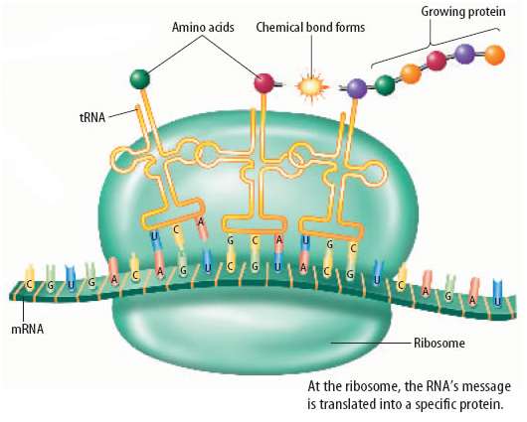

1. Identify the process in protein synthesis as shown in the diagram above. (1 mark)

_______________________________________________________________________________

1. Outline the steps involved in this process to form the end product. (4 marks)

_______________________________________________________________________________

_______________________________________________________________________________

_______________________________________________________________________________

_______________________________________________________________________________

_______________________________________________________________________________

_______________________________________________________________________________

14) a) Using your understanding of epigenetics, explain why identical twins are preferred subjects for research than fraternal twins and that twins are chosen over a large span of ages. (2 marks)

_______________________________________________________________________________

_______________________________________________________________________________

_______________________________________________________________________________

_______________________________________________________________________________

_______________________________________________________________________________

b) How is epigenetic inheritance different from genetic inheritance? (2 marks)

_______________________________________________________________________________

_______________________________________________________________________________

_______________________________________________________________________________

_______________________________________________________________________________

_______________________________________________________________________________

15) Complete the table below comparing both DNA and RNA. (4 marks)

|  |  |  |
| --- | --- | --- |
| **Source** | **DNA** | **RNA** |
| Number of Strands |  |  |
| Complementary Base to Adenine |  |  |
| Type of Sugar in Backbone |  |  |
| Function |  |  |

16) On the diagram of foetal circulation below, there are 2 structures labelled A and B that change at child birth.

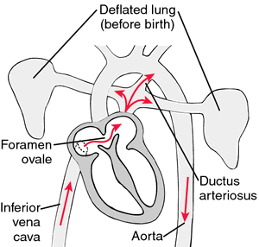

A.

B.

1. Name both of the structures below: (2 marks)

A: _______________________________________________________________________________

B: _______________________________________________________________________________

(b) There is a 3rd structure, not present in the diagram, that is also no longer needed by the baby after birth. Give the name of this structure and what its function is in the developing foetus. (2 marks)

_______________________________________________________________________________

_______________________________________________________________________________

17) Complete the table below, outlining the differences between the processes of spermatogenesis and oogenesis. (3 marks)

|  |  |  |
| --- | --- | --- |
|  | **SPERMATOGENESIS** | **OOGENESIS** |
| Age of individual when the  process starts occurring |  |  |
| Number of product gametes at  the end. |  |  |
| Number of polar bodies  Produced. |  |  |

18) Label the diagram of the female reproductive system below: (6 marks)

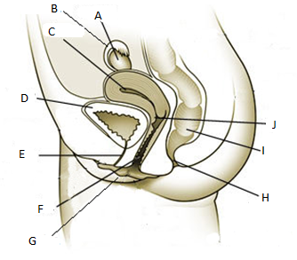

A: _______________________________________________________________________________

B: _______________________________________________________________________________

C: _______________________________________________________________________________

E: _______________________________________________________________________________

F: _______________________________________________________________________________

J: _______________________________________________________________________________

19) Infertility refers to the biological inability of a person or couple to conceive under natural conditions. Some types of infertility can be overcome with in-vitro fertilization (IVF). Explain the procedure used in IVF. (4 marks)

_______________________________________________________________________________

_______________________________________________________________________________

_______________________________________________________________________________

_______________________________________________________________________________

_______________________________________________________________________________

_______________________________________________________________________________

_______________________________________________________________________________

**Extended Response Section 13 Marks**

20) Jennifer is 45 years old and has just developed the symptoms of Huntington’s disease. Her father, James, is 70 Years old and is hospitalised with the disorder, but her mother, Anne, two years younger than her father, does not have the condition. Jennifer’s husband, John, also 45 years old, does not have Huntington’s disease, and there is no history of the condition in his family. Jennifer’s older brother, Malcolm, does not have the disease.

Jennifer and John have two children, Andrew (25 years old) and Michele (21 years old). Michele is married to Tony, who is the same age as her brother, and she has just given birth to a child called Darren. There is no history of Huntington’s disease in Tony’s family.

1. Construct a pedigree to show all the individuals in the family. Indicate the individuals who have Huntington’s disease by shading the relevant circles or squares. (5 marks)
2. Write down the possible genotypes of James, Anne, Jennifer and John. Explain the symbols you are using. (4 marks)
3. What is the probability that Michele has inherited Huntington’s disease? Using a punnet square, set out the cross between Michele’s parents in full. (4 marks)

__________________________________________________________________________________

__________________________________________________________________________________

__________________________________________________________________________________

__________________________________________________________________________________

__________________________________________________________________________________

__________________________________________________________________________________

__________________________________________________________________________________

__________________________________________________________________________________

__________________________________________________________________________________

__________________________________________________________________________________

__________________________________________________________________________________

__________________________________________________________________________________

__________________________________________________________________________________

__________________________________________________________________________________

__________________________________________________________________________________

__________________________________________________________________________________

__________________________________________________________________________________

__________________________________________________________________________________

__________________________________________________________________________________

__________________________________________________________________________________

__________________________________________________________________________________

__________________________________________________________________________________

__________________________________________________________________________________

__________________________________________________________________________________

__________________________________________________________________________________

__________________________________________________________________________________

__________________________________________________________________________________

__________________________________________________________________________________

__________________________________________________________________________________

__________________________________________________________________________________

__________________________________________________________________________________

__________________________________________________________________________________

__________________________________________________________________________________

__________________________________________________________________________________

__________________________________________________________________________________

__________________________________________________________________________________

__________________________________________________________________________________

__________________________________________________________________________________

__________________________________________________________________________________

**END OF ASSESSMENT**